In this video we will discuss, generating hyperlinks using actionlink html helper, for navigation between MVC pages.   
  
[Please watch Part 8](http://csharp-video-tutorials.blogspot.com/2013/05/part-8-data-access-in-mvc-using-entity.html), before proceeding.

We want to display all the employees in a **bulletted list** as shown below. Notice that all the employee names are rendered as **hyperlinks**.  
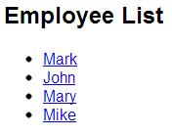   
  
**When the hyperlink is clicked**, the user will be redirected to employee details page, displaying the full details of the employee as shown below.  
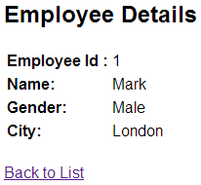

Copy and paste the following **Index**() action method in **EmployeeController** class. This method retrieves the list of employees, which is then passed on to the view for rendering.  
public ActionResult Index()  
{  
    EmployeeContext employeeContext = new EmployeeContext();  
    List<Employee> employees = employeeContext.Employees.ToList();  
  
    return View(employees);  
}  
  
At the moment, we **don't have a view** that can display the list of employees. To add the view  
**1.** Right click on the Index() action method  
**2.** Set  
View name = **Index**  
View engine = **Razor**  
Select, **Create a stronlgy-typed view checkbox**  
Select **"Employee"** from **"Model class"** dropdownlist  
**3.** Click Add  
  
At this point, **"Index.cshtml"** view should be generated. Copy and paste the following code in "Index.cshtml".  
@model IEnumerable<MVCDemo.Models.Employee>  
  
@using MVCDemo.Models;  
  
<div style="font-family:Arial">  
@{  
    ViewBag.Title = "Employee List";  
}  
  
<h2>Employee List</h2>  
<ul>  
@foreach (Employee employee in @Model)  
{  
    <li>@Html.ActionLink(employee.Name, "Details", new { id = employee.EmployeeId })</li>  
}  
</ul>  
</div>  
  
**Points to Remember:**  
**1.** @model is set to IEnumerable<MVCDemo.Models.Employee>  
**2.** We are using Html.ActionLink html helper to generate links

**Copy and paste the following code in Details.cshtml**  
@Html.ActionLink("Back to List", "Index")